THE OVERVIEW ARCHITECTURE OF OPERATING SYSTEM:

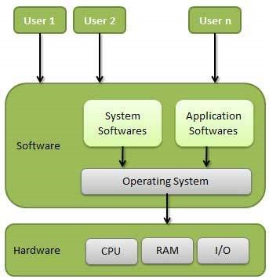

Device drivers here!

3 main roles of OS:

1. **Management of Software and Hardware**: The OS is a core system software responsible for managing and coordinating all other software applications and hardware components. It controls resources like the CPU, memory, storage, and peripheral devices, ensuring they are used effectively and efficiently.
2. **Bridge Between Software and Hardware**: The OS serves as an intermediary between software applications and hardware. It abstracts hardware details and provides system services, enabling application software to run without worrying about specific hardware configurations.

*Example: Consider a typical scenario where a user wants to print a document from a word processing application, such as Microsoft Word or Google Docs. Here's how the OS plays the intermediary role:*

* + - *Software Application:*

*The word processing application does not need to know the specific details of the printer hardware. It relies on the operating system to handle these details.*

* + - *Operating System:*

*The OS manages the communication between the application and the printer. It does this by utilizing device drivers, which are software programs designed to interface with specific hardware components.*

* + - *Device Drivers:*

*The OS uses a printer driver to translate the print command from the application into a format that the printer understands. The driver handles hardware-specific details like printer model, paper size, resolution, and other settings.*

1. **Graphical User Interface (GUI):** The OS often provides a graphical user interface (GUI) to make interactions with the system more intuitive and user-friendly. The GUI offers visual elements like windows, icons, menus, and buttons, allowing users to interact with software applications without needing to know complex command-line instructions.

Operating System - Functions

To brief, Following are some of important functions of an Operating System:

* Process Management
* I/O Device Management
* File Management
* Network Management
* Main Memory Management
* Secondary Storage Management
* Security Management
* Command Interpreter System: the Shell - an interface between user and OS interaction
* Control over system performance
* Job Accounting: a feature that tracks system resource usage by various processes, users, or groups,
* Error Detection and Correction
* Coordination between other software and users
* Many more other important tasks

https://www.javatpoint.com/deadlock-vs-starvation